Let’s create a docker image by manually installing software’s in container
- Lets install a nginx in some container and create a image out of it
- lets create a container in a interactive mode
docker container run -p 8082:80 -it ubuntu:22.04 /bin/bash
# apt update
# apt install nginx -y
# service nginx start
- Now lets create a docker image from running container
- In the docker host
docker commit <container-name/id>
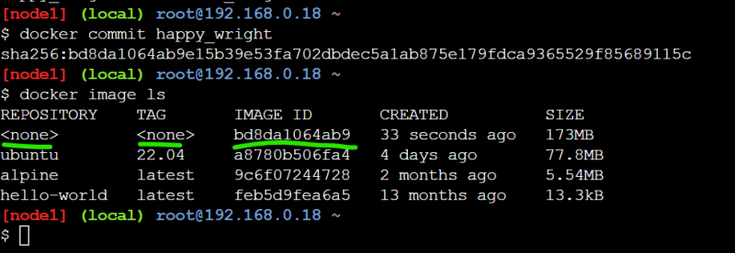
* Now lets create an image and tag based the image id
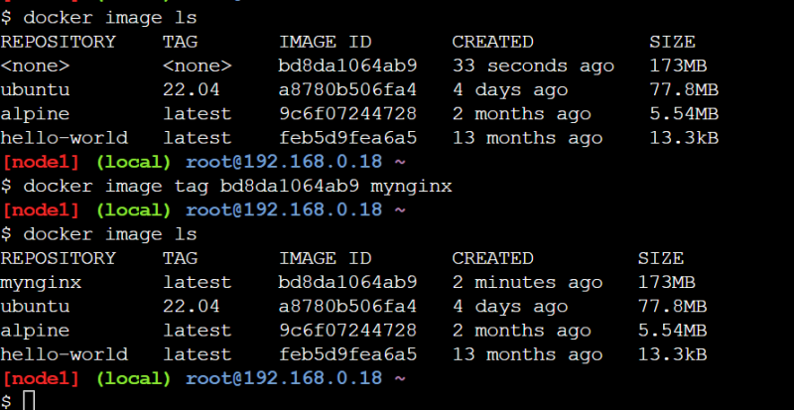
This approach creates images but no history of changes are available.

